1.**Write a Java program to calculate the final grade of a student based on their scores in**

**assignments, midterm, and final exam.**

**Variables: String studentName, int assignmentScore, int midtermScore, int finalExamScore,**

**String finalGrade**

**Test case**

**// Input**

**studentName = &quot;Alice&quot;;**

**assignmentScore = 85;**

**midtermScore = 78;**

**finalExamScore = 92;**

**// Expected Output: Alice&#39;s final grade is B.**

public class StudentGradeCalculator {

public static void main(String[] args) {

String studentName = "Alice";

int assignmentScore = 85;

int midtermScore = 78;

int finalExamScore = 92;

String finalGrade = calculateFinalGrade(assignmentScore, midtermScore, finalExamScore);

System.out.println(studentName + "'s final grade is " + finalGrade + ".");

}

public static String calculateFinalGrade(int assignmentScore, int midtermScore, int finalExamScore) {

double totalScore = (assignmentScore * 0.2) + (midtermScore * 0.3) + (finalExamScore * 0.5);

if (totalScore >= 90) {

return "A";

} else if (totalScore >= 80) {

return "B";

} else if (totalScore >= 70) {

return "C";

} else if (totalScore >= 60) {

return "D";

} else {

return "F";

}

}

}

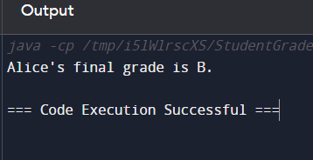

**Write a Java program to calculate the mileage of a car given the distance traveled and fuel**

**consumed.**

**Variables: String carModel, double distanceTraveled, double fuelConsumed, double**

**mileage**

**Test Case:**

**// Input**

**carModel = &quot;Toyota Camry&quot;;**

**distanceTraveled = 300;**

**fuelConsumed = 15;**

**// Expected Output: The mileage of Toyota Camry is 20.0 miles per gallon.**

public class CarMileageCalculator {

public static void main(String[] args) {

String carModel = "Toyota Camry";

double distanceTraveled = 300;

double fuelConsumed = 15;

double mileage = calculateMileage(distanceTraveled, fuelConsumed);

System.out.println("The mileage of " + carModel + " is " + mileage + " miles per gallon.");

}

public static double calculateMileage(double distanceTraveled, double fuelConsumed) {

if (fuelConsumed == 0) {

return 0;

} else {

return distanceTraveled / fuelConsumed;

}

}

}

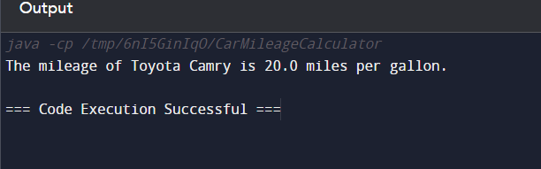

**Write a Java program to calculate the fine for overdue books in a library. The fine is calculated**

**based on the number of days overdue.**

**Variables: String bookTitle, int daysOverdue, double finePerDay, double totalFine**

**Test Case:**

**// Input**

**bookTitle = &quot;Harry Potter&quot;;**

**daysOverdue = 5;**

**finePerDay = 0.50;**

**// Expected Output: The fine for Harry Potter is $2.50.**

public class LibraryFineCalculator {

public static void main(String[] args) {

String bookTitle = "Harry Potter";

int daysOverdue = 5;

double finePerDay = 0.50;

double totalFine = calculateFine(daysOverdue, finePerDay);

System.out.println("The fine for " + bookTitle + " is $" + totalFine + ".");

}

public static double calculateFine(int daysOverdue, double finePerDay) {

return daysOverdue * finePerDay;

}

}

